Journal of Advanced Medical and Dental Sciences Research
@Society of Scientific Research and Studies
Journal home page: www.jamdsr.com doi: 10.21276/jamdsr ICV 2018= 82.06

(e) ISSN Online: 2321-9599; (p) ISSN Print: 2348-6805

Case Report
Implant Supported Mandibular Overdenture – Case Report

Nupur Rathi ¹, Roma Goswami ², Khurshid A Mattoo³

¹ Assistant professor, Department of Prosthodontics, Teerthankar Mahaveer dental college, TMU;
² Professor, Department of Prosthodontics, Subharti dental college, SVSU;
³ Assistant professor, Department of Prosthodontics, College of dentistry, JU;

ABSTRACT:
A complete denture prosthesis that is not integrated to the jaws can never give a patient the confidence in functional activity associated with dentition. Implant supported overdenture is a treatment option that has overcome this lacunae of conventional complete dentures. We present a case of an elderly female patient who, despite her age responded well to placement of two implants on which a mandibular overdenture was attached using a ball and socket attachments. The abutment retainer was attached to the denture with respective ‘O’ rings provided with the precision attachment. The denture was attached to the abutment directly in the patient's mouth using a fast setting duralay resin.
Key words: Ball and socket ,O-ring , precision attachment, overdenture, osseointegration.
Received: 28 August, 2019 Revised: 6 October, 2019 Accepted: 8 October, 2019
Correspondence author: Dr. Khurshid A Mattoo, Assistant professor, Department of Prosthodontics, College of dentistry, JU

This article may be cited as: Rathi N, Goswami R, Mattoo KA. Implant Supported Mandibular Overdenture – Case Report. J Adv Med Dent Scie Res 2019;7(11):128-130.

Introduction
The results of the complete denture prosthesis have improved with the advent of dental implants since the problem of retention and stability that is inherited to conventional complete denture is largely overcome by implants and its attachment to the complete denture. However, three things are perhaps important for implant supported prosthesis. Firstly, the affordability by the patient for implant supported prosthesis are expensive treatment except in institutes where they are given free to the patient. Secondly, the patients’ medical condition which should accept the implant since it is a foreign body to which normal body cells have to adapt rather than to react. Thirdly, the skill of the multidisciplinary team that will plan the prosthesis designing, through analysis and teamwork. ^{1, 2} Although the number of the desired implant depend upon the biomechanics of the existing oral condition, a completely resorbed residual alveolar ridge can be successfully restored with a minimum two implant supported prosthesis. this article describes one such case of successful rehabilitation of a severely resorbed mandibular residual alveolar ridge in which a two staged implant was placed over which an overdenture was retained using precision attachment.

Case report
An elderly female patient aged 72 years reported to the department of prosthodontics with a chief complaint of inability to use her existing dentures for mastication. Medical, social and drug histories were non contributory to the existing condition and future treatment plan. Extra oral (Fig 1A) and intra oral findings were positive and did not reveal any abnormal or negative findings. The patient was wearing the existing denture for last one year while she had used three sets of complete dentures till the date of her present treatment. Previous complete dentures had resulted in mandibular residual ridge resorption, which is why mandibular denture was loose and resulted in mastication that was not as per the satisfaction of the patient. The patient was presented with various treatment options out of which implant supported mandibular complete denture was the first choice. Depending upon the biomechanical analysis and patients affordability, the choice between placement of two or more implants was determined. The patient consented to a two implant fixture supported mandibular overdenture opposing a single complete maxillary denture. Routine clinical and laboratory procedures for a new conventional complete denture were started till a conventional complete denture with a bilateral balanced occlusal scheme was fabricated. The mandibular denture was duplicated at the stage of conventional complete denture insertion using a duplicate flask in which a clear acrylic autopolymerising acrylic resin (DPI) was poured.
On the day of surgery, two previously decided implant location areas were isolated on the surgical guide from the incisal edge to the base (Fig 1B). Surgical incision followed by tissue reflection were performed under local anesthesia (Fig 1C). Two implant fixtures (Adin - Touareg TM implants of 11.5 mm length and 3.75 mm diameter) were placed within the bone, the alignment of which was verified using implant guide pins (Fig 1D, E). Surgical cover screws were placed after flap approximation and primary closure was done with suture placement. Post-surgical care and instructions were given and after a period of fifteen days, the sutures were removed. Denture surface was adjusted and relined with a heat cure soft liner (GC Reline Soft TM) and the patient was discharged for follow up till the period of osseointegration was complete. In the second stage of surgery, the implant fixtures were exposed and the fit of corresponding abutment was verified following which healing collars were placed (Fig 2 A).

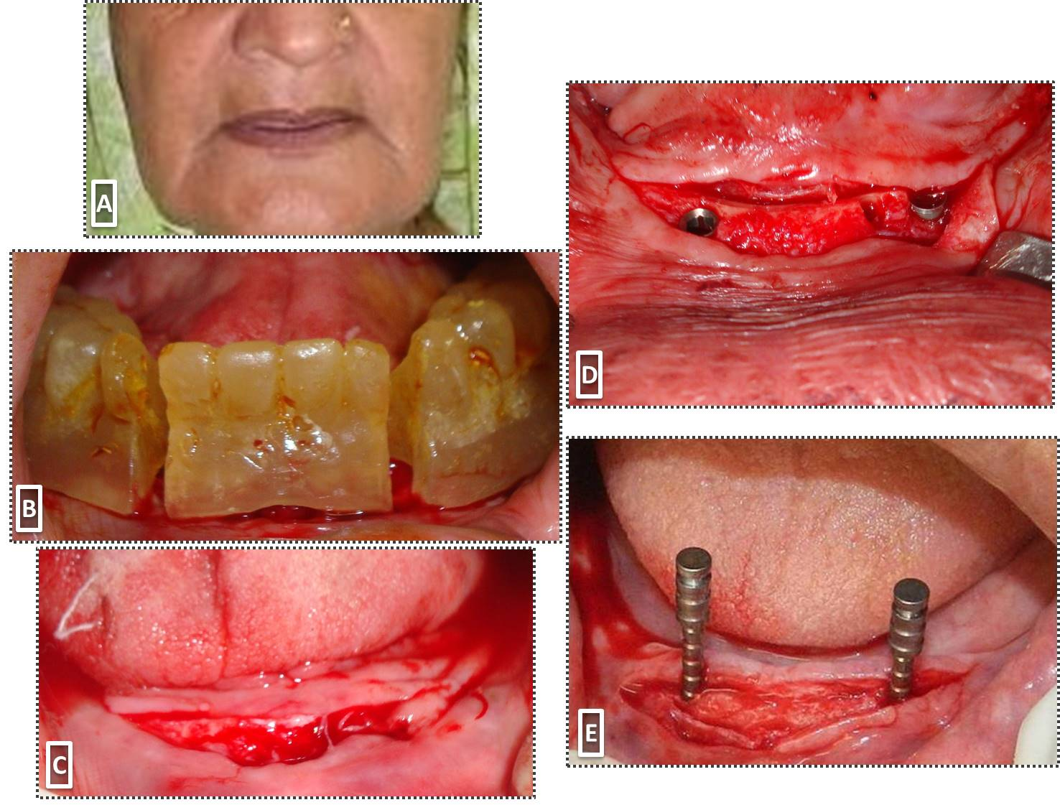

Figure 1: (A) Extra oral view (B) surgical guide (C) incision and flap reflection (D) implant fixtures in place (E) Guide pin verification
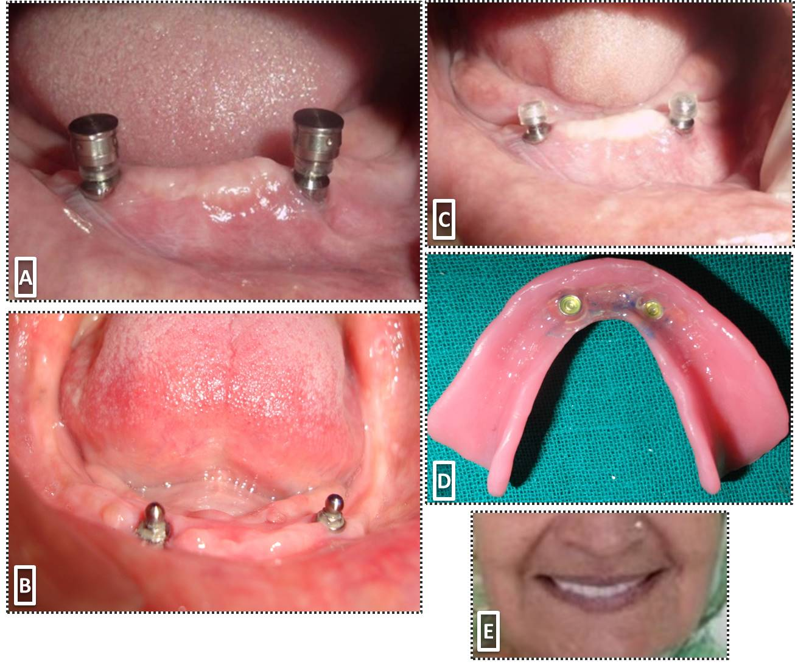
Figure 2:(A) implant fixture with respective analogues (B) Implant abutment with a ball and socket attachment (C) O ring attachment for denture placed on the ball (D) finished overdenture (E) Extra oral view after denture insertion

In the next stage, the ball and socket over denture abutment of 2 mm diameter (NP-0022) were seated with radiographical verification (Fig 2 B). The attachments were then fixed to implant fixtures using two O rings (Fig 2 C) under the denture. The complete denture was relieved to accommodate the attachment following which vents were made towards the lingual side for removal of excess resin. A fast setting pattern resin was then flowed into the space and the denture was locked in centric during the process of acrylic polymerization. Excess resin was removed from the tissue surface of the denture (Fig 2 D) and the denture was adjusted for minor occlusal discrepancies. The patient continued to wear the denture and was extremely satisfied with the outcome of the implant supported overdenture (Fig 2 E).

Discussion
The completely edentulous span of a human being occurs twice in a lifetime. One at birth and the other in the later part of life which varies on average above 50 years of age, depending on how well one maintains his natural dentition. The second phase of complete edentulousness may vary from 5 to even 30 years during which one has to wear a complete denture prosthesis. The oral cavity, especially the residual alveolar bone is not built up to support a complete denture prosthesis which is the reason it undergoes resorption over a period of time. As the bone resorbs in the mandible, the wearing of the complete denture becomes more and more difficult. Yet we see some patients who have severely resorbed ridge, but are satisfied with their prosthesis. The difference between the two types of patients is the patient’s ability to adapt its tongue to a new role which is to hold the denture rather than displace the denture. Nevertheless, with the advent of osseointegrated implants one can overcome the problems associated with poor ridge foundations by placing a minimum of two implants over which one can fabricate a complete denture. The use of implants in various numbers has proven to provide predictable prosthodontic results.³ The two implant mandibular overdenture is minimally invasive, simple and is affordable by even those who have less resources. ⁴⁻⁶
The fabrication technique of such overdenture especially when used with a ball and socket attachment is not cumbersome and error making can be easily accommodated without the need for repeating the procedure. The implant supported overdenture has been shown to achieve higher clinical success even with conventional complete denture treatment in the mandible. ⁷

Conclusion
Implants are rejected by most of the patients in the poor nation because of the cost associated with such prosthesis. A two implant supported overdenture is an excellent prosthetic option that improves life quality of a completely edentulous patient who has undergone mandibular resorption after wearing complete dentures over a period of time.

Acknowledgements
The authors would like to acknowledge the efforts of the staff of the department of oral surgery and periodontology for their significant role in the multidisciplinary team that treated the patient.
References
- Laney WR, Tolman DE, Keller EE, et al: Dental implants: Tissue-integrated prosthesis utilizing the osseointegration concept. Mayo Clin Proc 1986;61:91-97
- Parel SM: Implants and overdentures: The osseointegrated approach with conventional and compromised applications. Int JOral Maxillofac Implants 1986;1:93-99
- Albrektsson T, Zarb G, Worthington P, et al: The long term efficacy of currently used dental implants: A review and proposed criteria of success. Int J Oral Maxillofac Implants 1986;1:11-24
- Parel SM: Implants and overdentures: The osseointegrated approach with conventional and compromised applications. Int JOral Maxillofac Implants 1986;1:93-99
- Engquist B, Bergendal T, Kallus T, et al: A retrospective multicenter evaluation of osseointegrated implants supporting overdentures. Int J Oral Maxillofac Implants 1988;3:129-134
- Naert I, Quirynen M, Theuniers G, et al: Prosthetic aspects of osseointegrated fixtures supporting overdentures. A 4-year report. J Prosthet Dent 1991;65:671-680
- Zarb GA, Schmitt A: The longitudinal clinical effectiveness of osseointegrated dental implants: The Toronto study. Part II: The prosthetic results. J Prosthet Dent 1990;64:53-61

